THE THINKING MOMS’ REVOLUTION

STUDY – IONCLEANSE® BY AMD

Treatment Effectiveness for Children
on the Autism Spectrum
July 16, 2015
The Thinking Moms’ Revolution
Naples, Florida
INTRODUCTION
Who is TMR?

The Thinking Moms’ Revolution is made up of twenty-three moms and one brave dad. Their group stretches from Montana to Malaysia to Montreal. While parenting children with autism spectrum disorder, chronic childhood diseases and disabilities, they came together to collaborate about biomedical, alternative healing modalities and dietary interventions, as well as doctors and researchers developing cutting edge treatments. In the process they became a tight-knit family dedicated to helping their children lose their diagnoses.

Armed with shared experience, research papers and the close relationships established with doctors who care about underlying medical conditions, these parents are effectively disseminating knowledge about autism in ways that had not been possible until the advent of social media.

TMR continues its transformation into a powerful knowledge base, offering information and enlightenment to families dealing with autism and other environmental illnesses through a daily blog (www.thinkingmomsrevolution.com), a best-selling book, eConferences, events, local and national press and a 501c3 not-for-profit organization, TEAM TMR.

Who is Team TMR?

TMR is well known for demanding action, so it naturally shifted forward, from support and fellowship to an additional mission of offering financial assistance to families.

Team TMR was created as a 501(c)3 not-for-profit organization whose purpose is to fund a family grant program.

Team TMR is committed to turning the tide of the autism epidemic and continues to inspire a social thought movement. Their belief in recovery serves to make families stronger and to make healing more realistic. The faith and knowledge originally inspired by The Thinking Moms’ Revolution has kept these parents from surrendering.

The core belief of Team TMR is that all children deserve to live free from physical and emotional pain, in whatever ways are apparent and beneficial to their life’s journey.

The TMR Study
The primary mission of TMR is to share their stories and inspire hope by spreading the message that biomedical and alternative interventions are effective in treating children with autism.

They believe that the current autism epidemic is a toxicity problem, which once addressed correctly can be reversed. Rejecting the opinion that autism is incurable, they believe that autism is treatable.

After being introduced to A Major Difference, Inc., of Centennial, CO. AMD which manufactures the IonCleanse® Detoxification Footbath System, several TMR members used the machines with excellent results. This led to the idea to conduct a study on the efficacy of treatments using ionic detoxification footbath technology.

Please note: AMD agreed to provide the IonCleanse® for use at no cost to the study participants. Study participants were able to purchase the IonCleanse® system at 60% discount at the conclusion of the study. Study participants were not required to change any of their treatment protocols before or during the study.

AMD is a leading resource of toxin awareness and technology to cleanse and purify the body. More information is available through their website, www.amajordifference.com.

The basic protocol specified the use of detox footbaths every other day, for a minimum of 15 minutes per session, over a period of four months from January through April 2015.

A sample population of 28 children, with their families, volunteered to participate in the 2015 TMR study. Four participants opted out of the study within the first 30 days. There were several families who had more than one child enrolled.

The active study was preceded by an evaluation survey conducted prior to initiating the footbath sessions. The evaluation was then repeated at the end of each one-month period. A total of 5 surveys per individual participant were completed over the four-month study period.

The survey results were collected and compared. The data was statistically analyzed and displayed in a series of tables, graphs, and cumulative distribution curves, displayed later in this report.

The ATEC Survey
The survey format utilized is the “Autism Treatment Evaluation Checklist” (ATEC) developed by Bernard Rimland and Stephen M. Edelson of the Autism Research Institute, San Diego, CA.

The ATEC is a highly regarded assessment tool for the evaluation of children diagnosed as being on the autism spectrum. The ATEC is specifically designed to measure treatment effectiveness.

The ATEC is not a diagnostic checklist. It provides several subscale scores as well as a total score to be used for comparison at a later date. The lower the score, the fewer the problems.

The ATEC is a one-page form designed to be completed by parents, teachers, therapists and other caretakers who have close observational experience with the subject.
It consists of 4 subtests:
- Speech/Language Communication (14 items);
- Sociability (20 items);
- Sensory/ Cognitive Awareness (18 items);
- Health/Physical/Behavior (25 items).

Many parents and teachers use the ATEC to monitor how well the child is doing over time. In addition, researchers have used the ATEC to document improvement following an intervention, by comparing the baseline ATEC scores with the post-treatment ATEC scores.

Since the primary function of the ATEC is to measure the efficacy of interventions, it is expected that a number of ATECs will be submitted for each individual periodically during the trial of the intervention, subsequent to the initial (baseline) ATEC.

Unlike most other tools, the ATEC is not copyrighted and may be used free of charge by any researcher. Copies are available on request from the Autism Research Institute or at the ARI web site, www.autism.com.

Users of the ATEC may have it scored free of charge (4 subscores and a total score) by entering the responses via computer to the ATEC form on the website for immediate and free-of-cost scoring. ATEC forms are only accepted online.

An explanation of how to interpret ATEC scores can be found at: http://www.autism.com/index.php/ind_atec_report

The Survey Results

ATEC Results by Study Participant
(by age from youngest to oldest)
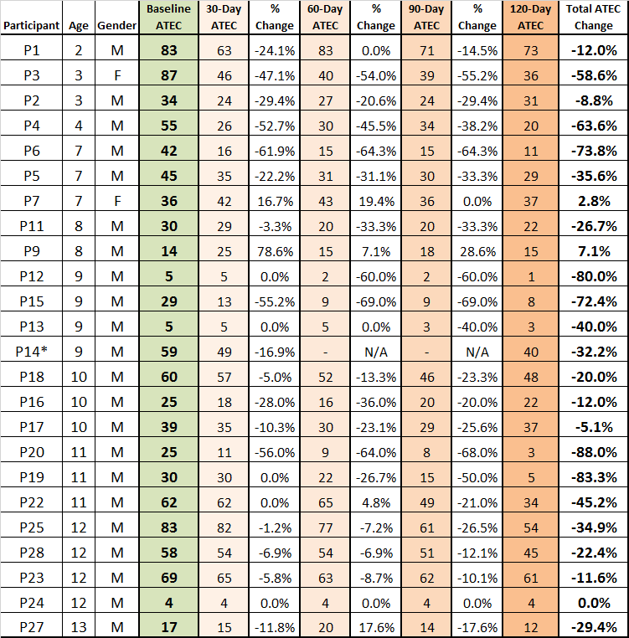

Participant 14 did not submit all surveys thus none of the P14 data was used in Figure 2 and Figure 3
Figure 1

Figure 2

Figure 1 and Figure 2 - Observations/Comments
- ATEC - On average, the greatest ATEC reductions occurred in subsequent months
  - Month 1 (14.6%), Month 2 (8.21%), Month 3 (7.32%), Month 4 (5.55%)

- AGE – Age does not appear to dictate results
  - Ages 2-4 average ATEC reduction was 38.2%
  - Ages 6-10 average ATEC reduction was 37.4%
  - Ages 11+ average ATEC reduction was 31.1%

- ATEC change was variable
  - 89% of participants realized a progressive improvement from 5.1% to 88%,
when comparing baseline to 120 day results
  - 25% of participants (6) had a reduction greater than 63%; (3) had 80%+ reductions
  - 20.8% of participants (5) had a reduction between 32.2% and 58.6%
  - 16.7% of participants (4) had a reduction between 20% and 29.4%
  - 20.8% of participants (5) had a reduction between 5.1% and 12%
  - 4.2% of participants (1) had no change in (this person had an ATEC of 4)
  - 8.3% of participants had an increase between 2.8% and 7.1%

Cumulative Distribution Analysis

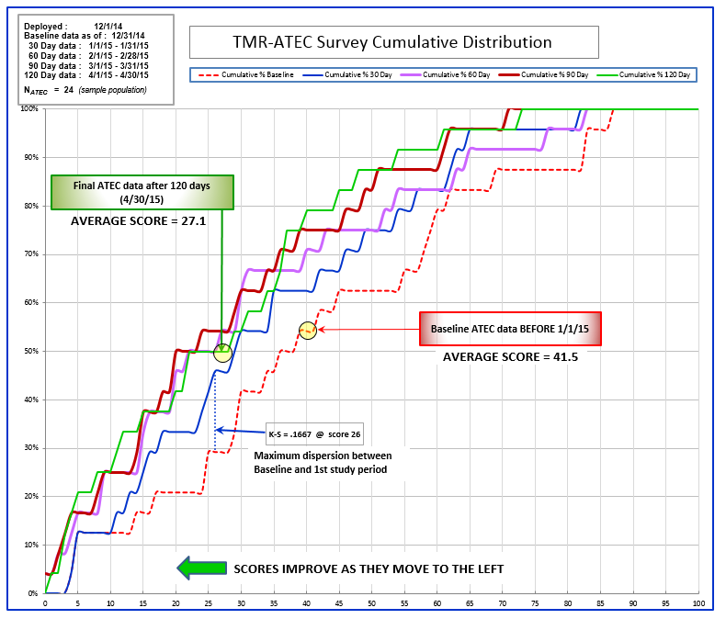
Figure 3

Figure 3 – Observations/Comments
- Initial Comments:
- The data curves were smoothed but the choppy appearance is due to the low sample size. If the sample size had been larger, at 1000 or 10,000 data points, the plots would have been more evenly distributed, yielding symmetrical graph lines.
- Trend lines are not necessary or helpful in this chart.
- The direction of improvement is to the left. Lower scores = better results.
- The K-S line = the score where the widest dispersion (greatest improvement) exists between two data curves.

II. Performance:
100% of baseline scores are below 87, 50% are below 38, average = 41.5
100% of 30 day scores are below 82, 50% are below 29, average = 33.8
100% of 60 day scores are below 83, 50% are below 26, average = 30.5
100% of 90 day scores are below 71, 50% are below 23, average = 27.5
100% of 120 day scores are below 73, 50% are below 28, average = 27.1

III. Observation of positive change:
- The greatest initial improvement occurred at score 26, between the baseline and 30 day
results.
- Improved scores continued, at a lesser rate of change, through the 60 and 90 day periods.
- The 120 day results were mixed within the same range as the previous 30 and 60 day
data.

IV. Summary:
- Only 54% of participants were below the initial average score (41.5), at beginning of
study.
B. By end of study, 79% of participants were below the initial average score (41.5).

Conclusion:
The efficacy of treatments using ionic detoxification footbath technology has been validated
through the TMR-ATEC Survey. Observed results, combined with mathematical analysis, have
shown clearly that detoxification is an essential element in the autism recovery process.

The cumulative distribution of survey scores (Figure 3) illustrates the progressive nature of this protocol. The chart shows the percentage of the sample (left axis) that has recorded a specific score (bottom axis). The five separate curves show the scores of the sample group at distinct time intervals (0, 30, 60, 90, and 120 days).

The point of maximum scoring difference, between time intervals, was observed at score 26 between the baseline curve and the 30 day curve. This indicates the point of greatest improvement during the survey period. Note: “K-S” stands for the Kolmogorov–Smirnov test, which compares sample data with reference (baseline) data.

At the time of the baseline ATEC survey, the average score was 41.5, for the entire sample group. At conclusion of the survey (120 days), the average score for the entire sample group had
decreased to 27.1. This indicates an overall improvement of 35%.

The ATEC is specifically designed to measure treatment effectiveness. Lower scores indicate improvement of the individual participant. The chart shows that the study group, as a whole, obtained significant, positive benefit from the application of this technology. The curves moved steadily to the left during the survey period, indicating continual improvement of the group as a whole.

These results establish high confidence that continued use of the IonCleanse® Detoxification Footbath System can be used as an effective tool in the treatment of Autism Spectrum Disorder (ASD).

